**Worked out answers Statistics Practical 3 year 1: tests for categorical data comparing independent groups, paired tests and correlations**

1.

a) from the table: the total probability of dying in the insulin group is 0.324 (23 / 71) and in the group of insulin non-users: 0.259 (53 / 205). So the RD = 0.324 – 0.259 = 0.065

b) RR = 0.324 / 0.259 = 1.25

c) OR = (23 x 152) / (53 x 48) = 1.37

2.

Females use significantly more insulin than males (both Chi-square test and Fisher’s Exact test have a P < 0.001).

3.

We cannot use the Chi-square test now since two cell have expected counts less than 5 (see the footnote by the test). Fisher’s exact test is here no longer significant. Although the estimated difference between the proportions might be larger now, the test is less significant because of the lower numbers.

4.

Create a dataset with three variables and four cases like the one below:

Activate “Weight cases by”: in the menu **Data > Weight Cases** and fill in “number” for the weighing factor.

Make a cross tabulation of the variables sex and “colourblind” and ask for the Chi-square test.

The P-values of Fisher’s exact test is smaller than 0.05, we can reject the null hypothesis of independence. Boys have significantly higher probability to be colour blind than girls.

5a. H0: μsbp2 = μsbp1 or : μsbp2 - μsbp1 = 0

H1: μsbp2 ≠ μsbp1 or : μsbp2 - μsbp1 ≠ 0

5b.

Mean difference in blood pressure is 2.6259, with a standard deviation of 17.91971. Dividing this by √n gives us the standard error of the mean difference: 17.91971/√278= 1.07475. The t statistics (“how many standard errors does the mean difference differ from zero”) is then:

t= 2.6259 / (17.91971/√278)= 2.6259 / 1.07475 = 2.443, with df = n-1=277.

We can use the table of the standard normal distribution instead of the t- distribution if we have that many degrees of freedom: the two sided P-value is 2∙0.00734 = 0.01468.

This value is smaller than alpha (= 0.05), so we will reject the null hypothesis and conclude: mean SBP2 is significantly higher than the mean SBP1.

The 95% CI for the difference in means: 2.6259 ± 1.96∙1.07475 = [ 0.52; 4.73 ]

5c.

The conclusions from the SPSS output are almost identical to the one we calculated by hand. There is a small difference in the limits of the 95% CI; the critical t-value for df = 277 is (rounded) 1.97 instead of 1.96.

5d.

Two sided P value = 0.015, the 95% CI [0.510 ; 4.742], which does not include (a difference of) 0 (reflecting a significant result).

Note: if you fill in sbp1 first, you will find -2.626 as mean difference. The conclusion is still the same of course.

5e.

The results are exactly the same as in the one-sample t-test. After 2 years, the mean blood pressure has significantly increased.

6a.

The differences show a distribution close to normal.

6b.

**Sign Test**

|  |  |  |
| --- | --- | --- |
| **Frequencies** | | |
|  | | N |
| syst. blood pressure after 2 years - syst. blood pressure at start | Negative Differencesa | 115 |
| Positive Differencesb | 159 |
| Tiesc | 4 |
| Total | 278 |
| a. syst. blood pressure after 2 years < syst. blood pressure at start | | |
| b. syst. blood pressure after 2 years > syst. blood pressure at start | | |
| c. syst. blood pressure after 2 years = syst. blood pressure at start | | |

|  |  |
| --- | --- |
| **Test Statisticsa** | |
|  | syst. blood pressure after 2 years - syst. blood pressure at start |
| Z | -2,598 |
| Asymp. Sig. (2-tailed) | ,009 |
| a. Sign Test | |

According to the sign test, there is a significant difference between the paired blood pressures. Of 4 individuals SPB2 is equal to SBP1, of the 274 other pairs, almost 58% (159 out of 274) has SBP2 higher than SBP1.

**Wilcoxon Signed Ranks Test**

Wilcoxon’s signed rank test is also significant.

7a.

A paired test for binary data: McNemar’s test.

7b.

The Chi—square approximation: $X^{2}=\frac{({19-6)}^{2}}{25}=\frac{169}{25}=6.76$. With 1 df, P ≈ 0.01.

With CDF.Binom: P(X ≤ 6) if X ~B(25, 0.5) = 0.0073. Two sided: 0.0146.

In SPSS: make a dataset with three variables, A, B an number, and four cases:

As before, use **Data > Weight** **Cases** to make “number” the weighting factor.

Use **Analyze > Descriptive Statistics > Crosstabs** and choose **Statistics > McNemar** to get the correct test):

All three methods lead to the conclusion that significantly more individuals are positive about A.

8a.

(Make sure that weight is on the vertical axis).

There seems to be a (somewhat linear) relation, on average have taller individuals higher weights.

8b. The distributions of both height and weight are reasonably normal, so we can use Pearson’s correlation coefficient. For the total sample this is 0.53 (P < 0.001). So there is a significant positive linear correlation between height and weight.

8c.

Use **Data > Split File** based on sex, to separate males and females.

Pearson’s correlation coefficient for males equals 0.515, for females this is 0.395.

The correlation in the total sample is not a (weighted) mean of the correlation of males and females. This is due to the fact that the domain of observations for females is different from the domain of observations for males; the total ranges of height and weight increase. An extreme example of this phenomenon is the following data:

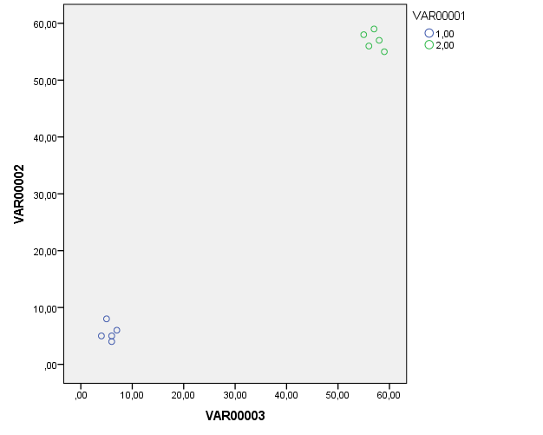

In this simple example, there is no significant Pearson correlation in each of the two groups separately, but as a total sample, Pearson’s correlation coefficient is highly significant.

9a.

Both distributions are rather skewed, so we cannot use Pearson’s correlation: we will use Spearman instead. Spearman’s correlation coefficient is 0.197, with a P<0.001. So there is a significant positive linear correlation between duration of diabetes and HbA1c..

